

Attendance Policy
2026-2027

Document Control:
This document has been approved for operation within: | Apex Collaborative Trust
Status | Statutory
Owner | Executive Headteacher
Date effective from | 27.08.26 | Date of next review | 26.08.27
Review period | 12 months | Version | 1

Version | Changes identified

Why are attendance and punctuality so important?
Our aim in the Apex Collaborative Trust is to help you to understand the benefit of excellent attendance at school.
Persistent absenteeism seriously affects your schooling and your life after school. Being absent results in loss of learning, which in turn results in lower levels of achievement and grades, which in turn results in lower employment prospects.
- These things are fundamental to our trust values:
  - We are ambitious and believe all students can achieve excellent attendance.
  - We are respectful. Arriving on time demonstrates good manners and consideration for others.
  - We are collaborative. We support and challenge everyone to achieve high standards.
- Regular school attendance is important to give children the best possible start in life.
- Research suggests students who attend school regularly are at less risk of getting involved in antisocial behaviour or crime.

Attendance Bands

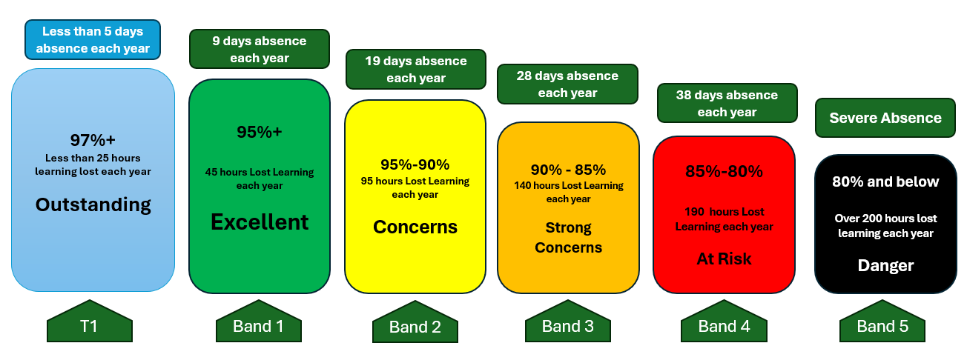

The negative impact of frequent lateness:

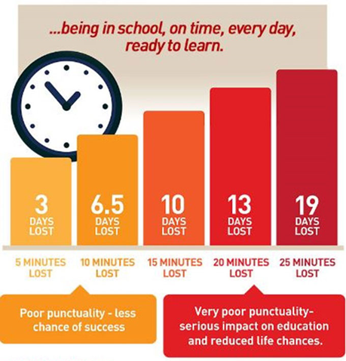

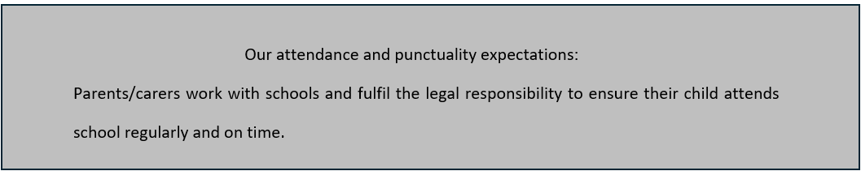

- How we manage attendance – our daily routines

  - The School Day:
- Gates open at 8:45 am and close at 8:55 am. After that, children are classed as late.
- Children arriving after register closes (9:30 am) will be marked as U (unauthorised).
- School finishes at 3:30 pm
- Each school day involves a morning and afternoon session.
- Afternoon registration is at 1:00 pm. Children arriving after 1:30 pm will be marked U (unauthorised).

  - If your child is absent:
Phone the school (option 2 on the school phone number) before 8:30 am to speak to the school office or (if unavailable) leave a message on the answer phone with:
- child’s name, year group
- name of person making the call
- date of absence
- a detailed reason for absence.

This must be done on the first day of absence and EVERY subsequent day.
You can also report an absence by leaving a message on the school absence voicemail Tel:01282 865996 or by emailing admin@laneshaw.apex-trust.org.
Mrs Singleton is available to offer support and guidance to help ensure all pupils achieve the best possible attendance at school.

2. If your child has Persistent Absence (below 90% attendance) please refer to Section 6

2.1 How we will manage absence:
  - Contact from home regarding absence
  - No message received call to be made to parents / carer by 10:00 am.
  - Parent / carer encouraged to send child to school as soon as possible where appropriate
  - If no contact is made, a home visit will be initiated as soon as possible from the first day
  - No one home / answers the door police/social services will be contacted.

2.2 Late to school:
We will require a reason for lateness and offer support where appropriate.

In all circumstances, the following will apply:
Week 1: Two or more late arrivals: contact made with parents/carers by the school office.
Week 2: Two or more late arrivals: again, a letter sent home from school.
Week 3: Two or more late arrivals again parents / carers will be invited in for a meeting with the headteacher. At this point a Punctuality Agreement will be put in place with a monitoring period agreed, referrals to external agencies including the local authority’s Pupil Attendance Support Team will also be discussed.

3.Roles and responsibilities, including Key people and contact details

3.1 The Senior Attendance Champion is responsible for:
- Setting a clear vision for improving and maintaining good attendance.
- Establishing and maintaining effective systems for tackling absence.
- Ensuring systems are followed by all staff and all staff have a strong grasp of absence data to focus the collective efforts of the school.
- Monitoring and evaluating progress regularly, including the effectiveness of the school’s strategies and processes.
- Holding formal conversations with parents, and pupils if age-appropriate, where engagement in support is proving challenging.

3.2 The School Attendance Officer is responsible for:
- Monitoring attendance and attendance registers, including liaising with the local authority.
- Communicating with students/parents regarding attendance and following up on poor attendance.
- Informing the Headteacher when a penalty notice is appropriate.

3.3 All Staff are responsible for:
- Where designated, completing the register accurately and on time.
- Taking an active role in supporting good attendance for all students and modelling good attendance behaviour.
- Using professional judgement and knowledge of individual students to decide whether welfare concerns should be escalated.

3.4 Students are responsible for
- Attending school every day.
- Arriving punctually at the start of the day and to all lessons.
- Attending prepared and equipped for the day.

3.5 Parents are responsible for:
- The attendance and punctuality of their children at school.
- Providing accurate and up-to-date contact details (minimum of 2 emergency contact numbers).
- Work with and support school to promote good attendance and punctuality.

4.How we encourage good attendance… including how we manage appointments

4.1 Rewards/incentives
Excellent attendance is an expectation for all students. At the same time, we will use acknowledgement, praise and rewards as an integral part of our approach to encourage high standards and improvement.

The school encourages consistent attendance and punctuality through a collective school reward system.

4.2 Unplanned absence
We will mark absence due to illness as authorised unless the school has a genuine concern about the authenticity of the illness or has ongoing attendance concerns. In such cases the absence will be recorded as unauthorised, and parents/carers will be notified.

If the student has had an extended period of absence through illness and/or the authenticity of the illness is in doubt, the school may ask the student’s parent/carer to provide medical evidence, such as a prescription, appointment card or other appropriate form of evidence. In addition, a referral to the school nurse may be suggested.

4.3 Planned absence & leave of absence
Parents will be expected to make medical or dental appointments outside of school hours wherever possible. Attending a medical or dental appointment will only be counted as authorised if the student’s parent/carer notifies the school in advance of the appointment and provides evidence of the appointment. Parents will be responsible for ensuring their child misses only the amount of time necessary to attend the appointment.

The school will only grant a student a leave of absence in exceptional circumstances and will consider requests on an individual basis. The school will expect parents to contact the headteacher in writing, using the Leave of Absence Request Form at least two weeks prior to the proposed start date. The form is available on school websites.

The school shares the DfE’s view is that it generally “does not consider a need or desire for a holiday or other absence for the purpose of leisure and recreation to be an exceptional circumstance”.
If term-time leave is not granted, taking a student out of school will be recorded as an unauthorised absence and may result in sanctions, such as a penalty notice. The school cannot grant leave of absence retrospectively; therefore, any absences that were not approved by the school in advance will be marked as unauthorised.

For absence linked to a family holiday we will request evidence of flight times. Should these not be provided, we may unauthorise any subsequent absence either side of the stated holiday dates and undertake a home visit. Where evidence suggests, on the balance of probability, that 5 or more days absence is entirely due to a holiday rather than for medical reasons, the school may submit the appropriate forms to the local authority for them to issue a penalty notice.

4.4 Following up absence
Where any child we expect to attend school does not attend, or stops attending, the school will:
- Follow up on their absence with their parent/carer to ascertain the reason.
- Ensure proper safeguarding action is taken where necessary.
- Identify whether the absence is approved or not.
- Identify the correct attendance code to use
To safeguard our students, parents/carers of students should contact school on the first day of absence giving a reason for the absence. If school does not receive a call, then a phone call will be made by the school, or a text message sent. In most cases, a member of the attendance staff will visit home. In extreme circumstances and where there may be safeguarding concerns, a police welfare check would be considered.

- How we track the attendance of children and how we ensure our work is effective

  - Attendance register
The Trust uses Bromcom to keep attendance registers and ensures that they are accurate and can be easily analysed and shared as appropriate.
Registers record whether every pupil is:
- Present
- Attending an approved off-site educational activity
- Absent
- Unable to attend due to exceptional circumstances

  - Use of data – information for parents
- Attendance will be regularly reported to parents through half-termly trackers and is live on MCAS.
- If attendance is a concern parents/carers will be contacted more frequently to improve attendance.
- Examples of the tracker letter is included in appendix A.

- How we will reduce persistent or severe absence

  - Reducing persistent absence
If a pattern of absence becomes problematic, the attendance officer will work collaboratively with the pupil and their parents to improve attendance by addressing the specific barriers that prevent the pupil from being able to attend school regularly.

Where these barriers are related to the student’s experience in school, e.g. bullying, the attendance officer will work with the headteacher and any relevant school staff, e.g. the DSL and SENCO, to address this.

We will take a stepped approach to ensure excellent attendance for all students, as follows:
- Early intervention has been shown to be vital to maintain excellent attendance. Parents/carers may be notified when attendance drops below 97%, taking into account a child’s historical attendance.
- A child whose attendance falls below 95% will miss 2 weeks of school over the year. For this reason, we may communicate further with parents/carers to share our concerns and offer support.
- A student whose attendance falls below 92% is at risk of being considered persistently absent. In this circumstance we will usually communicate with parents/carers to outline a plan to improve attendance and prevent the child from falling into persistent absence.
- All pupils falling below a 90% attendance level are classed as persistent absentees. Parents/carers may be contacted and may be expected to attend a meeting. If we determine it necessary, parents/carers and pupils may need to sign an agreement/contract to improve attendance to school. The school will liaise with other agencies working with students and their families to support attendance, e.g. social services.
- Failure to improve attendance will lead to a fixed penalty notice. Parents/carers will be informed of these measures through letters sent from school. Parents/carers must act on the information in the letters to ensure they are not subjected to fixed penalty notices or prosecution. 10 unauthorised absences (10 half days) over a rolling period of 10 weeks can lead to a fixed penalty notice. This can include being late to school after the register closes.
- Section 444 (1) of the Education Act 1996 states: If a child of compulsory school age who is a registered pupil at a school fails to attend regularly at the school, his parent is guilty of an offence. Section 444 (1A) goes on to state: If in the circumstances mentioned in subsection (1) the parent knows that his child is failing to attend regularly at the school and fails to cause him to do so, he is guilty of an offence.
- The Head or Deputy Head will aim to visit any PA pupil who is absent from school as a high priority. This may include a home visit from the first day of absence.

- Use of sanctions including fixed penalty notices

The school will allow sufficient time for attendance interventions and engagement strategies to improve students’ attendance; however, progress will be carefully monitored and where engagement strategies have not had the desired effect, the attendance officer will consider:
- Holding a formal meeting with parents
- Working with external agencies where appropriate
- Engaging children’s social care where there are safeguarding concerns.
We work closely with the Local Authority, who support us with strategies to manage individual cases. There is an expectation in Lancashire that we tackle attendance concerns robustly. Where the above measures are not effective, the headteacher will issue a fixed penalty notice in line with the Local Authority’s code of conduct.

Where the above measures are not effective, the headteacher will issue a fixed penalty notice in line with the Local Authority’s code of conduct.

Where attendance still does not improve following a fixed penalty notice, the school will work with the Local Authority to take forward attendance prosecution as a last resort.

• The first penalty notice issued to a parent in respect of a particular pupil will be charged at £160 if paid within 28 days. This will be reduced to £80 if paid within 21 days.
• A second penalty notice issued to the same parent in respect of the same pupil is charged at a flat rate of £160 if paid within 28 days.
• A third penalty notice cannot be issued to the same parent in respect of the same child within 3 years of the date of issue of the first. In a case where the national threshold is met for a third time (or subsequent times) within those 3 years, alternative action will be taken instead. This will often include considering prosecution, but may include other tools such as one of the other attendance legal interventions.
Headteachers have a duty to do everything possible to support excellent attendance, including the use of penalty notices where all measures to support families have failed or where parents/carers taken a child out of school for unauthorised leave of absence.
The decision on whether or not to issue a penalty notice may take into account:
- The number of unauthorised absences occurring within a rolling 10 week period
- One-off instances of irregular attendance, such as holidays taken in term time without permission
- Where an excluded pupil is found in a public place during school hours without a justifiable reason

- Monitoring/evaluation of the policy

The policy has been developed by a steering group consisting of the attendance coordinators and other senior leaders from across the Trust. Its effectiveness will be reviewed on a termly basis.

The trustees are responsible for monitoring attendance figures for the whole school on at least a termly basis. They also hold the CEO and headteachers to account for the implementation of this policy. A link governor in each school holds senior staff to account for overall attendance figures and consistent implementation of this policy. This includes ensuring that this policy, as written, does not discriminate on any grounds, including, but not limited to, ethnicity/national origin, culture, religion, gender, disability or sexual orientation.

The headteacher is responsible for ensuring implementation of this policy across the school, ensuring all parents are aware of the school’s attendance expectations and procedures and that every pupil has access to full-time education, acting as early as possible to address patterns of absence.
The headteacher will also ensure the local authority is informed if a penalty notice is appropriate for them to initiate this.

- Appendix 1 Definitions and the attendance codes we use.

Definitions:
Persistent absence is when a pupil overall absence equates to 10% or more of their possible sessions.
Severe absence is when a pupil enrolment’s overall absence equates to 50% or more of their possible sessions.

The following codes are taken from the DfE’s guidance on school attendance.
Code | When to use
Present codes
/ | Present in school am
\ | Present in school pm
L | Late arrival before register is closed
C | Leave of absence granted by the school
C1 | Leave of absence for the purpose of participating in a regulated performance or undertaking regulated employment abroad.
C2 | Leave of absence for a pupil subject to a part-time timetable.
Absent codes
H | Leave of absence for a family holiday granted by school
E | Excluded from school but no alterative provision made
I | Illness
M | Medical or dental appointment
R | Religious observance
S | Study leave (to be used sparingly for Year 11)
T | Traveller absence
Unauthorised absence from school codes
G | Holiday not granted by school
N | Reason for absence not yet provided
O | Absent without authorisation
U | Arrived in school after registration closed
Attending an approved educational activity
D | Dual registered at another school
B | Off-site educational activity
J | At an interview with prospective employer or another educational establishment
K | Attending education provision arranged by the LA
Q | Unable to attend the school because of a lack of access arrangements
P | Participating in a supervised sporting activity
V | Educational visit or trip
W | Work experience
Y1 | Unable to attend due to transport normally provided not being available
Y2 | Unable to attend due to widespread disruption to travel
Y3 | Unable to attend due to part of the school premises being closed
Y4 | Unable to attend due to the whole school site being unexpectedly closed
Y5 | Unable to attend as pupil is in criminal justice detention
Y6 | Unable to attend in accordance with public health guidance or law
Y7 | Unable to attend because of any other unavoidable cause
Administrative codes
X | Non-compulsory school age pupil not required to be in school
Z | Prospective pupil not on admission register
# | Planned whole or partial school closure

- Appendix 2 2. Legislation and guidance

This policy has due regard to all relevant legislation and statutory guidance including, but not limited to, the following:
- Education Act 1996
- Equality Act 2010
- The Education (Pupil Registration) (England) Regulations 2006 (As amended)
- The Children (Performances and Activities) (England) Regulations 2014
- Children and Young Persons Act 1963
- DfE (2026) ‘Working together to improve school attendance’
- DfE (2026) ‘Keeping children safe in education 2026’
- DfE (2025) ‘Children missing education’

This policy operates in conjunction with the following school policies:
- Child Protection and Safeguarding Policy
- Complaints Procedures Policy
- Behaviour Policy
- SEND Policy
- Supporting Pupils with Medical Conditions Policy
- Social, Emotional and Mental Health (SEMH) Policy
- Children Missing Education Policy
- Attendance Officer Home Visit Policy
- Pupils with Additional Health Needs Attendance Policy

Appendix 3 Half termly letter templates summarising attendance levels – green, amber and red.

Dear Parent/Carer,

ATTENDANCE

We have made it a priority to support all pupils within our school to achieve excellent levels of punctuality and attendance. It is the expectation that [INSERT NAME] attends school regularly and on time to ensure his/her learning progresses. The following chart shows how poor attendance can impact on a child’s learning and their educational outcomes.

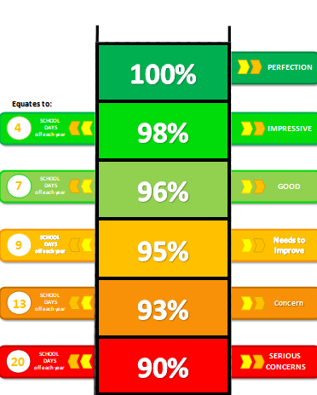

Current attendance so far: 100%

I am very pleased with [INSERT NAME]‘s attendance so far and I would like to take this opportunity to thank you for your support with this.

Yours sincerely,

Headteacher

Dear Parent/Carer,

ATTENDANCE

We have made it a priority to support all pupils within our school to achieve excellent levels of punctuality and attendance. It is the expectation that [INSERT NAME] attends school regularly and on time to ensure his/her learning progresses. The following chart shows how poor attendance can impact on a child’s learning and their educational outcomes.

Current attendance level

Should you have any questions or concerns regarding attendance or feel school could provide any additional support, please make contact via the school office.

Yours sincerely,

Headteacher

Dear Parent/Carer,

ATTENDANCE

We have made it a priority to support all pupils within our school to achieve excellent levels of punctuality and attendance. It is the expectation that [INSERT NAME] attends school regularly and on time to ensure his/her learning progresses. The following chart shows how poor attendance can impact on a child’s learning and their educational outcomes.
Current attendance level

As is evident from the graphic above, your child’s current attendance level is a cause for concern. We will continue to monitor this very carefully and it is essential that we work together to bring about an improvement.

Yours sincerely,

Headteacher

