
SEN INFORMATION REPORT 2026/27

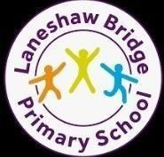
Name of the Special Educational Needs/ Disabilities Coordinator:
Ms Gaynor Canty
Contact details:
Email: gcanty@ apex-trust.org Alternatively, an appointment to see Ms Canty can be made via the school office and via telephone on01282 865996

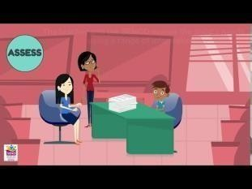
1 - A great introduction to the SEND system, very relevant even though it is based on the provision of another local authority we all have to follow the SEN Code of Practice 2014 and the graduated response.
The kinds of SEND we provide for.


Laneshaw Bridge School is a mainstream school with an inclusive ethos.
At Laneshaw Bridge we aim to create a secure, stimulating and happy learning environment where all pupils' needs are met and challenged regardless of gender, ethnicity, ability or background. We want all our pupils to achieve their best and have a successful transition onto the next phase of their learning and into adult life.
We want everyone at Laneshaw Bridge School to learn to have ambition, respect for one another and collaborate together.
In order to achieve the very best for our children with Special Educational Needs and Disabilities (SEND), we work hard to ensure that:
- we welcome and include all pupils into our community
- we have strong, supportive links with parents and carers
- we identify Special Educational Needs as early as possible
- we follow an effective assess - plan - do - review cycle to monitor and track continuous progress
- liaise closely with specialist SEND professionals who can support both staff and pupils
We can make provision for children with a range of needs, including cognition and learning, communication and interaction, and social, emotional and mental health difficulties. We take the advice of specialist teachers and other professionals to help us further support the children in our care. Any additional provision for pupils in our school is detailed on provision maps which are monitored by the Special Educational Needs and Disabilities Coordinator on a regular basis.
Furniture is modern and of a suitable height appropriate to the age group of children being taught in that classroom. All classrooms have interactive whiteboards. Computers are available if necessary. The children are taught using multi-sensory techniques and additional resources are purchased as required.
School also works with other agencies e.g. Occupational Therapy and SALT (Speech and Language Therapist) to support those children who have specific physical needs and/or access requirements, creating individual access/care plans.
The building is easily accessible for all pupils being on one level. Emergency evacuation procedures (PEEPs) are in place to provide 1:1 supervision of disabled students.

How we identify SEN

The identification of SEN is built into the overall approach to monitoring the progress and development of all children. All children are assessed regularly and progress is tracked and monitored. Any children who are falling significantly outside of the range of expected academic achievement in line with predicted performance indicators, have social or emotional difficulties, are vulnerable or have specific diagnosed needs will be monitored.
At Laneshaw Bridge we have children with a range of SEN. We support these children in many different ways to ensure that they have access to a broad and balanced curriculum. They may have additional needs in one or more areas as set out in the SEN Code of Practice, 2015.

Communication and Interaction
We have a number of pupils who experience speech and language difficulties. Consequently, we have teachers and teaching assistants who support children with Speech and Language Difficulties in a 1-1 situation or small group settings. This may include pupils who find it difficult to understand what others are saying or have difficulties with fluency or forming sounds, words or sentences. We have a range of resources which are used to support children’s Speech and Language development and we work closely with Speech and Language Therapists.



Cognition and Learning
We are experienced in supporting children with Cognition and Learning Difficulties through high quality teaching and effective adaption to the curriculum. This includes children with Specific Learning Difficulties such as dyslexia (specific difficulties with reading or spelling), dyscalculia (specific difficulties with maths) or dyspraxia (specific difficulties with coordination). We also support children with moderate learning difficulties and children on the Autistic Spectrum. For example, we support children by breaking down activities into smaller, achievable chunks; providing appropriate resources including the use of technology or multisensory activities and through providing adult support. We also run a number of interventions. The teachers plan a provision map for each of the children, called a POP, in their class that require additional support and this is monitored by the SENCo.
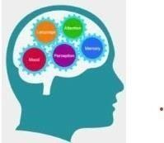

Social, Emotion and Mental Health Difficulties
For some children, difficulties in their social and emotional development can mean that they require additional or different provision. We support these children through pupil mentoring and social skills groups. We involve outside agencies such as CAMHS (Child & Adolescent Mental Health Service) and the PRU (Pupil referral unit) if necessary.

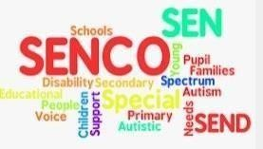

Sensory or/and Physical Needs
We work closely with outside agencies to provide support for children in our school who have sensory or physical difficulties. Where necessary, we make adaptations to the curriculum or environment in order to make lessons and learning opportunities accessible to them. We hold regular meetings with outside agencies and parents to review the approaches that are in place.
At Laneshaw Bridge school we endeavour to achieve maximum inclusion for all children whilst ensuring all their individual needs are met.
Teachers provide adapted learning opportunities for all the children within the school and provide materials and resources appropriate to the children’s interests and abilities. This ensures that all children have full access to the school curriculum.
All members of staff in school have a responsibility for maximising the achievement and opportunity of all learners, including those with SEND. Staff are aware of their responsibilities towards all learners and a positive and sensitive attitude is shown towards all pupils at all times. Laneshaw Bridge provides a very nurturing environment for all children.
How we consult with parents of children with SEND and involve them in their child's education.
- We are a child and family centred school, so you will be involved in all decision making about your child’s support.
- When we assess SEND we discuss it with you to determine whether your child’s understanding and behaviour are the same at school and home; we take this into account and work with you so that we are all helping your child in the same way to make progress.
- Parents are invited to a meeting with the class teachers on a termly basis. In the meeting parents/ child’s views will be used to support the class teacher in writing and reviewing targets for your child. Class teachers will then write them onto Individual Pupil Overview of Provision (POP)
- Your child will also have a Support Plan which will be up dated annually by the SENCo, class teacher, parents and the child. This is used by school and professionals to share information about your child’s specific needs.
- We also use homework to repeat and practice activities that are new and present an achievable challenge for the individual pupil.
- Talk to us – contact your child’s class teacher about your concerns initially. If you feel that you would like to speak to a senior member of staff, ask to arrange an appointment with the SENCo. Appointments can be arranged in person, by phone or by email. Please see the school contact details at the top of this report.
- If teachers have any concerns regarding a child in their class, they will discuss these concerns with parents and also with the SENCo. The targets of children who have an IEP (Individual Education Programme) are reviewed termly and teachers are formally asked at these key points of the year to reflect upon the progress of children on the SEN Register and to identify any other children of concern.
- If you continue to be concerned that your child is not making progress you may wish to speak to the special educational needs/ disabilities co-ordinator (SENCo).

How do you evaluate the effectiveness of the provision made for children and young people with special educational needs?
All children with SEND children have either: An Education, Health and Care Plan (EHCP) and/or an IEP, Individual Education Plan. All of these are reviewed regularly, as laid out above.

The SENCo reports annually on the efficient and effective use of resources for pupils identified as having
SEND. The monitoring and evaluation of progress of pupils with SEND is detailed in the Graduated
Approach section of the Policy for SEND. For pupils with an Education, Health and Care Plan, annual
reviews (6 monthly for under 5s) are carried out in accordance with the appropriate legislation and the SEND Code of Practice 2015;

The SENCo collects and analyses tracking data for all pupils on the SEND register and uses this, in conjunction with information gathered from other sources (SEND learning walks, professional dialogue, discussions with pupils and parents etc) to make a judgement on effectiveness. Children with SEND are expected to make at least the same progress as their peers because of the additional provision they receive. If this is the case, provision is judged to be effective. The SENCo reports to governors on the quality and effectiveness of SEND provision.

Any additional provision for all children (whether or not they have SEND) is carefully recorded
(‘mapped’) by the class teacher and/or SENCo. The cost of all such provision is calculated, based on the pro-rata cost of the allocated time for the member of staff delivering the provision (for internally sourced provision) or on actual billed costs (for external providers or specialist resources purchased). Concurrently, the progress of all children who are receiving additional provision is carefully tracked. This information is then scrutinised by the Senior Leadership Team and/or SENCo to ensure that the effectiveness and efficiency of provision is maximised.

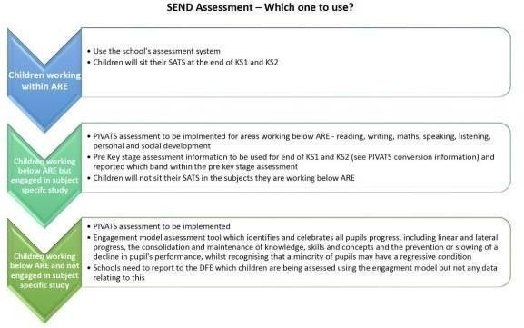

This flowchart explains how we use assessments in school to support and show the progress children are making.
How will my child/young person be included in activities outside the classroom, including school trips.
Children with Special Educational Needs and Disabilities are welcomed and actively encouraged to go on all trips (including residential) and to attend all clubs. Where appropriate, parents will be consulted from the planning stage and all reasonable adaptations and adjustments made to ensure that children with SEND can safely access and enjoy the social and skills development that such activities bring. The adaptations will usually be the result of the risk assessment and may include additional staffing (1:1 support if necessary), extra time allowances, amendments to the activity (e.g. through use of different equipment) etc.

What support will there be for my child/young person's overall well- being?

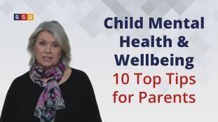
Laneshaw Bridge Primary aims to provide a safe, nurturing environment in which all pupils achieve their full potential and have the skills and confidence to meet the challenges of the future. All Teaching Staff record concerns about children in various files kept on the CPOMS system (behaviour/CP/racist/bullying/homophobic)

The school use CPOMS- (software for safeguarding and recording for staff). In addition, to supporting pupils and their families, the school liaises with all relevant specialist agencies such as the family and medical centres, Craven Prevention Team, CAMHS, paediatricians, speech therapists, occupational therapists, school nurse etc. Although none of these are based in school, some do come into school to carry out assessments and therapy, with parental permission.

In some cases, school or one of the other agencies may complete an EHA (Early Help Assessment) form with parents. This is an assessment and planning tool which is used to gather information about children and families in one place to help the family to decide what type of support is needed. It may be used to address an unmet educational need (as above) or an emotional or social need. More information for families about the EHA process is available here: https://www.safeguardingchildren.co.uk/ professionals/early-help/
Sometimes, a Team Around the Family (TAF) meeting is called to continue the system of support for the family. These are usually held in school and parents will always be involved.

The school has a variety of policies which cover health and wellbeing issues e.g. Medicines in School Policy, Accident / Incident Report Procedures Policy etc. The school’s Single Equality Policy is available for free on the website and via the school office on request.

Some medication, such as asthma inhalers are kept in the appropriate classroom. All other medication is kept in a locked cupboard in the office, or in the fridge in the school office. All medicine is recorded in a medicine book along with details of dosage and frequency; parents sign to grant authorisation to the school to administer to their child. Full records are kept in accordance with the appropriate policy.

A review of medical for individual children with specific needs, Care Plans are written at a meeting between a member of the school’s staff, the child’s parents, the child (when appropriate) and the School
Nurse. Laneshaw Bridge Primary is an inclusive school; all staff should know which children have Care Plans and who is trained to deal with them. Any new adults coming into school go through a short induction in accordance with the school’s Induction Policy to ensure they are made aware of any particular needs.

Some staff within school have had Paediatric First Aid training which is updated on a 3-yearly cycle. Additionally, staff receive training to deal with specific difficulties, when the need arises e.g. how to deal with a diabetic child or the use of Epi-Pens. Where a child’s health care needs may impact on their ability to access an educational trip or activity, additional advice is sought from parents and/or health care professionals, as appropriate. School deals with medical issues through a graduated response. Minor issues are dealt with by trained school staff but we would always err on the side of caution if it was felt that an illness, injury or medical attack was more serious and contact the emergency services. School will always try to contact parents/carers in these instances so it is really important that the office has up to date contact details including home and mobile telephone numbers.
How do you involve other bodies, including health and social services, local authority support services and voluntary organisations, in meeting the needs of children/young people with SEND and in supporting their families?
Within the school we have a culture of sharing good practice and expertise; this enables us to ensure our staff have as much knowledge as possible within the field of supporting children with SEND.
The environment is designed to support children with individual needs e.g. visual timetables, individual workstations etc as required.
As a school we work closely with any external agencies that we feel are relevant to supporting individual children’s’ needs within our school including: Health services including: GPs, school nurse, CAMHS (Child and Adolescent Mental Health Service), clinical psychologist, pediatrician, speech and language therapists, occupational and physiotherapists; Children’s Services including: Early Help locality teams, social workers; educational psychologists and specialist advisory teachers.

What arrangements do you make in relation to the treatment of complaints from children/young people and their parents/carers with special educational needs concerning your provision made?
General information relating to SEND can be found on the school website, included within the SEND policy. This can be found on the policy page of the school website.

Further information is available from the SENCo/Head teacher. If you do not feel the school has followed up your concerns appropriately you can use the School Complaints Policy or in exceptional situations contact the SEN governor or Chair of Governors via the School Office.

The school has a complaints policy, which is available on the policy page of the school website.

Where can I find the contact details of support services for the parents of children/young people with SEND?

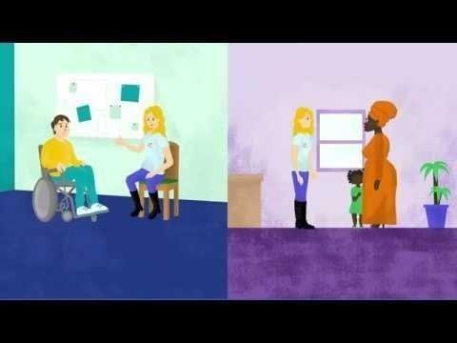
This video from The Council for Disabled Children provides more information about Information, Advice, and Support (IAS) services. It gives a good understanding of the support on offer to you through the SENDIASS service.
Where can I find information on where the local authority's local offer is published?
The SEND local offer is:
- information, advice, support and services
- provided by education, health, Lancashire County Council (the local authority) and voluntary organisations
- local to Lancashire
- for children and young people with special educational needs and disabilities (SEND) aged 0-25
- available in one place on our website at www.lancashire.gov.uk/send. SEND Directory https://senddirectory.lancashire.gov.uk/kb5/lancashire/directory/home.page
Search the directory for organisations that provide information, advice, support or activities in Lancashire and nationally, if relevant.
You should always check that the service or organisation meets your own requirements by contacting them directly.
The Lancashire local offer provides information on what services children, young people and their families can expect from a range of local agencies, including education, health and social care. Knowing what is out there gives parents more choice and therefore more control over what support is right for their child. Find out more at
https://www.lancashire.gov.uk/children-education-families/special-educational-needs-and-disabilities/

Lancashire SEND Information, Advice and Support Service is a statutory service which is run at ‘arm’s length’ from the Local Authority and provides free, confidential, impartial advice, guidance and support to parents of children with special educational needs and children and young people with SEND
Further support and information for parents can be found through: https://lancssendias.org.uk/

IPSEA: Offers free and independent legally based information, advice and support to help get the right education for children and young people with SEND: https://www.ipsea.org.uk
KIDS: A National Charity, that provides a wide range of services to disabled children, young people, and their families in England. Their services include: drop-in crèches and nurseries for the under 5s to youth clubs, short breaks and residential stays for young adults: https://www.kids.org.uk

Contact: A National Information and Advice service for families of disabled children: https://contact.org.uk

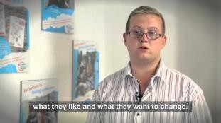
The Lancashire local offer provides information on what services children, young people and their families can expect from a range of local agencies, including education, health and social care. Knowing what is out there gives parents more choice and therefore more control over what support is right f or their child. Find out more at:
https://www.lancashire.gov.uk/children-education-families/special-educational-needs-and-disabilities/

