
Behaviour Policy

Document Control:
This document has been approved for operation within: | The Apex Collaborative Trust
Status | Statutory
Owner | Executive Headteacher and Head of School
Date effective from | August 2026 | Date of next review | August 2027
Review period | Annually | Version | 4

Version |  | Changes identified
2 | •  • | Page 12 – Managing Low Level Behaviours updated Page 13 – Updated ‘Managing Behaviour’ graphic
3 |  | - Changed Pennine Trust to Apex Collaborative Trust  - Updated Behaviour Process  - Updated School values
Contents
Scope and purpose
Behaviour expectations and pupils with SEN
Duties under Keeping Children Safe in Education 2022
Roles and responsibilities
The headteacher and the governing body
All staff
All pupils
Families
Definitions
Our mission and purpose
Our aims
Values and behaviours
Recognition, reward and praise
Detentions and corrections
Isolation and reflection
Reasonable force
Fixed term and permanent exclusion
Apex Collaborative Trust Learning Habits
Managing low level behaviour
Managing more significant behaviour
Prevention strategies and sanctions for unacceptable behaviour
Physical intervention
Isolation room/space
Behaviour report card

Policy Statement
The Apex Collaborative Trust recognises that the highest standards for behaviour is central to achieving the best education for our pupils. We achieve this through the promotion of a positive culture, building social norms, proactively teaching students how to behave well, as well as fair and transparent systems of rewards and sanctions.
We believe in the power of positive framing and in the certainty, not necessarily severity, of sanction in creating a culture conducive to learning and thriving in education.
We aim to give all pupils the knowledge and understanding that will enable them to become increasingly self-disciplined and able to make positive choices for themselves.
All our schools have consistently high expectations of behaviour for learning and overall conduct; firmly embedded practices and routines to establish a calm and purposeful environment; a clear framework of learning habits. We work as leaders across the Trust to ensure we have broad agreement on the reasonableness and proportionality of sanctions.
This policy should be read in conjunction with the following policies:
- Anti-Bullying
- Physical Intervention
- Child Protection and Safeguarding
- Equality and Diversity
- Exclusion
- Online Safety and Acceptable Use of Information Technology
- Staff Conduct
- SEND
- This policy is underpinned by the following legislation and guidance:
- Education Act (2002), as amended by Education Act (2011)
- Education and Inspections Act (2006)
- School Discipline [Pupil Exclusions and Reviews] – England – Regulations (2012)
- Equality Act (2010, revised 2018)
- Searching, Screening and Confiscation at Schools (2018)
- When to call the police: guidance for schools and colleges (NPCC)
- Keeping Children Safe in Education
- Behaviour in Schools
- Suspension and Permanent Exclusion

1. Scope and purpose
All our schools:
- have the highest expectations of pupil behaviour in order to maximise their opportunity to achieve
- ensure all pupils develop the excellent learning habits that they need to be successful in school and in life
- realise and celebrate the potential of all pupils through promoting independence, high self-esteem and enabling students to reach their full potential
- create an environment in which pupils are enabled to become mature, self disciplined, industrious and able to accept responsibility for their own actions
- have a no tolerance approach to all forms of child on child abuse, including bullying and cyberbullying, and work hard to create a positive and safe learning environment
- work to develop and support all staff to manage behaviour with a high level of professionalism, dignity and fairness in order to maintain a safe and purposeful environment
- build positive relationships between families, school and pupils through a three way partnership, makes clear the expectations of all three parties in developing and maintaining a safe and positive culture and an active partnership with parents and carers to support their children’s learning
These aims are supported by regular and pertinent staff training and practice; close family and community links; pupil organisation and opportunities in line with our Equalities Objectives; the boosting of pupils’ self-esteem through positive reinforcement and a broad balanced curriculum including extra-curricular activities and social and community events aimed at celebrating diversity whilst seeking and emphasising commonality.

2. Behaviour expectations and pupils with SEND
All our schools have a duty to manage pupil behaviour effectively, including for those with underlying needs, in order to maintain a safe, purposeful and effective learning environment. We aim to establish a culture that consistently promotes high standards of behaviour and provide the support needed for all pupils to achieve and thrive both in and out of the classroom. We aim to develop whole school approaches that foster a sense of belonging, facilitate learning, and benefit all pupils equally. Some pupils with SEND may have behaviours that arise from their additional needs and the law requires flexibility and responsiveness, often through provision that is ‘additional to or different from’ the main offer, in order to meet those needs. In addition, pupils with SEND may have behaviours that are not arising from their additional needs and other pupils’ behaviour may be arising from SEND that has not yet been identified or understood. We aim to establish behaviour systems that are consistent and based on high expectations as the norm, but are also flexible and responsive enough to support a wide range of needs and support all pupils to learn from their behaviour and move forward in a positive way. This should include directly teaching pupils the skills and understanding that underpins good behaviour, and anticipating likely triggers of challenging behaviour and putting provision in place to support and prevent it wherever possible.

3. Duties under Keeping Children Safe in Education 2022
We recognise that challenging behaviour, and in particular a change in a child’s behaviour, can be indicative of a child protection or wider safeguarding need. For this reason, all our behaviour systems, including sanctions, incorporate opportunities for restoration, relationship building, consideration of what support is required and, where appropriate, referral for further assessment. We prioritise the proactive teaching of the underlying skills and understanding that underpins our culture of high expectations, including ensuring all pupils know how to seek help if they need it. We take all forms of child on child abuse, including bullying and child on child sexual harassment and sexual violence, extremely seriously. More detailed information about this can be found in our Child Protection Safeguarding Policy and our Anti-bullying Policy.

4. Roles and responsibilities
The majority of our time in all our schools is spent reinforcing a culture of high expectations and positivity in order to maintain good order and discipline that allows pupils to maximise their potential. At times, pupils may make the wrong choices and, when this happens, we will take a proportionate and forward-thinking response in order to maintain our culture and progress positively. The lists below make clear the power and responsibility of the Apex Collaborative Trust, school governing bodies, the Headteacher and all staff to uphold a safe and secure environment in line with this policy. We also recognise that the strength of any behaviour policy or system is in how it is communicated and understood by all stakeholders, and the positive and trusting relationships between those stakeholders. It is crucial that each school shares its behaviour system clearly with all staff, pupils and families; that the implementation is supported by the three-way partnership between school, pupil and families; and that the school works cooperatively and reciprocally with other schools and key agencies.

5. The Headteacher and the Governing Body
- The Trust Board approves the Trust policy; it has a duty under the Education Regulations Act 2010 to ensure arrangements are made to safeguard and promote the welfare of students
- the Local Governing Body annually scrutinises and approves the individual school routines and practices
- the Headteacher is responsible for ensuring the school aligns to the Trust’s mission and values, follows Trust policy and that their individual school has strong behaviour practices to support staff in managing behaviour, including the use of sanction and praise / reward
- the Headteacher and staff have the power to use reasonable force and other physical contact in order to maintain and restore order (as stipulated in the Physical Intervention Policy), but cannot, under any circumstances, use force as a form of punishment. Corporate punishment of any kind is entirely illegal
- the Headteacher and delegated staff have the power to search pupils, screen electronic devices, and to confiscate property.
- the Headteacher and delegated staff have the power to discipline pupils outside of school hours if it is a school-related matter, or the pupil’s actions undermine the safety of anyone from our community or the good reputation of the Trust
- all schools have the power to impose detentions outside of school hours, without parental consent. However, we do always inform our parents when a detention or correction is to occur outside of the usual working day
- all our schools work actively within local partnerships (Local Authority
Partnership, Behaviour and Attendance Collaboration, Fair Access Protocol) to improve the standard of behaviour across the locality.

6. All staff
- Some staff, for example senior leaders and behaviour practitioners, may have additional responsibilities delegated to them by the Headteacher, for example the power to search, screen and confiscate items, in line with guidance and Trust policy
- all staff must have read and understood this policy and other related policies, and sign to say that they have read and understood them as part of the induction process
- staff are responsible for knowing and understanding the systems in place to support behaviour, upholding them within their school, and seeking support if necessary
- all staff will behave professionally and in a way that demonstrates appropriate behaviour to the pupils through learning by example
- staff are responsible for being responsive to signs of child on child abuse and acting swiftly and appropriately, in line with our Anti-bullying Policy and Keeping Children Safe in Education.

7. All pupils
As part of our ongoing commitment to maintaining a culture of safety and learning for all pupils, staff and visitors to our schools, pupils will receive ongoing direct learning opportunities through PSHE, as well as indirect learning opportunities through observing the professional behaviour of the adults around them.
This will include but is not limited to:
- learning how their behaviour impacts others and their own future selves
- learning about identity, protected characteristics, prejudice and discrimination
- learning about ways to seek help and support
- building trusting relationships with staff
- learning from the professionalism and conduct of staff
All pupils have a responsibility to behave in a way that does not disrupt the learning, wellbeing or safety of themselves, their peers or any adult in the academy or wider academy community.
The school operates a 'no touch' policy, meaning pupils should not engage in physical contact with others unless appropriate and permitted within the context of learning or play. Staff will apply this policy fairly and sensitively, taking into account behaviour that is appropriate for a child’s age, maturity, and individual needs. The language 'no touch' will be used across the school.

8. Families
All families agree our three-way partnership when their child enters the school. We expect families to work with us in supporting good behaviour that is conducive to learning and thriving in education and beyond and in upholding our positive culture. Our success as a Trust is built on this three-way relationship between the home, school and child

9. Definitions
For the purposes of this policy, the school defines “serious unacceptable behaviour” as any behaviour which may cause harm to oneself or others, damage the reputation of the school within the wider community, and/or any illegal behaviour. This includes, but is not limited to, the following:
- Discrimination – not giving equal respect to an individual on the basis of age, disability, gender identity, marriage and civil partnership, pregnancy and maternity, race, religion or belief, sex, and sexual orientation
- Harassment – behaviour towards others which is unwanted, offensive and affects the dignity of the individual or group of individuals
- Vexatious behaviour – deliberately acting in a manner so as to cause annoyance or irritation
- Bullying – a type of harassment which involves personal abuse or persistent actions which humiliate, intimidate, frighten or demean the individual being bullied
- Cyberbullying – the use of electronic communication to bully a person, typically by sending messages of an intimidating or threatening nature
- Possession of legal or illegal drugs, alcohol or tobacco
- Possession of banned items
- Truancy and running away from school Refusing to comply with disciplinary sanctions Theft
- Verbal abuse, including swearing, racist remarks and threatening language
- Fighting and aggression
- Persistent disobedience or destructive behavior

10. Our Mission and Purpose
Our mission statement encapsulates our approach and what we prioritise daily:
Make a difference in our communities by placing learning at the heart of all we do
We want to provide every child in our care with the best possible start in life and to motivate them to fulfil their individual potential and make a full contribution to their communities and to society.

11. Our Aims
Building on our mission, we have an ambitious vision for our young people and for the Trust:
Through a child-centred approach and exceptional educational experiences we will inspire excellence from all, develop independence, build confidence and ensure readiness for tomorrow.
We believe every child can achieve and we continually encourage high aspirations amongst pupils and staff. To this end, leaders across the Trust adopt an evidence informed approach to developing all aspects of school provision and are committed to high quality professional development of staff, so that we have an exceptional curriculum and pedagogy in all our schools. High quality pastoral care and support aligned with diagnostic assessment of needs and targeted interventions, help to ensure appropriate provision for every individual.
12. Values and behaviours
Three core values underpin all trust decisions and policies and are at the heart of every aspect of school life:
Ambition, Collaboration and Trust
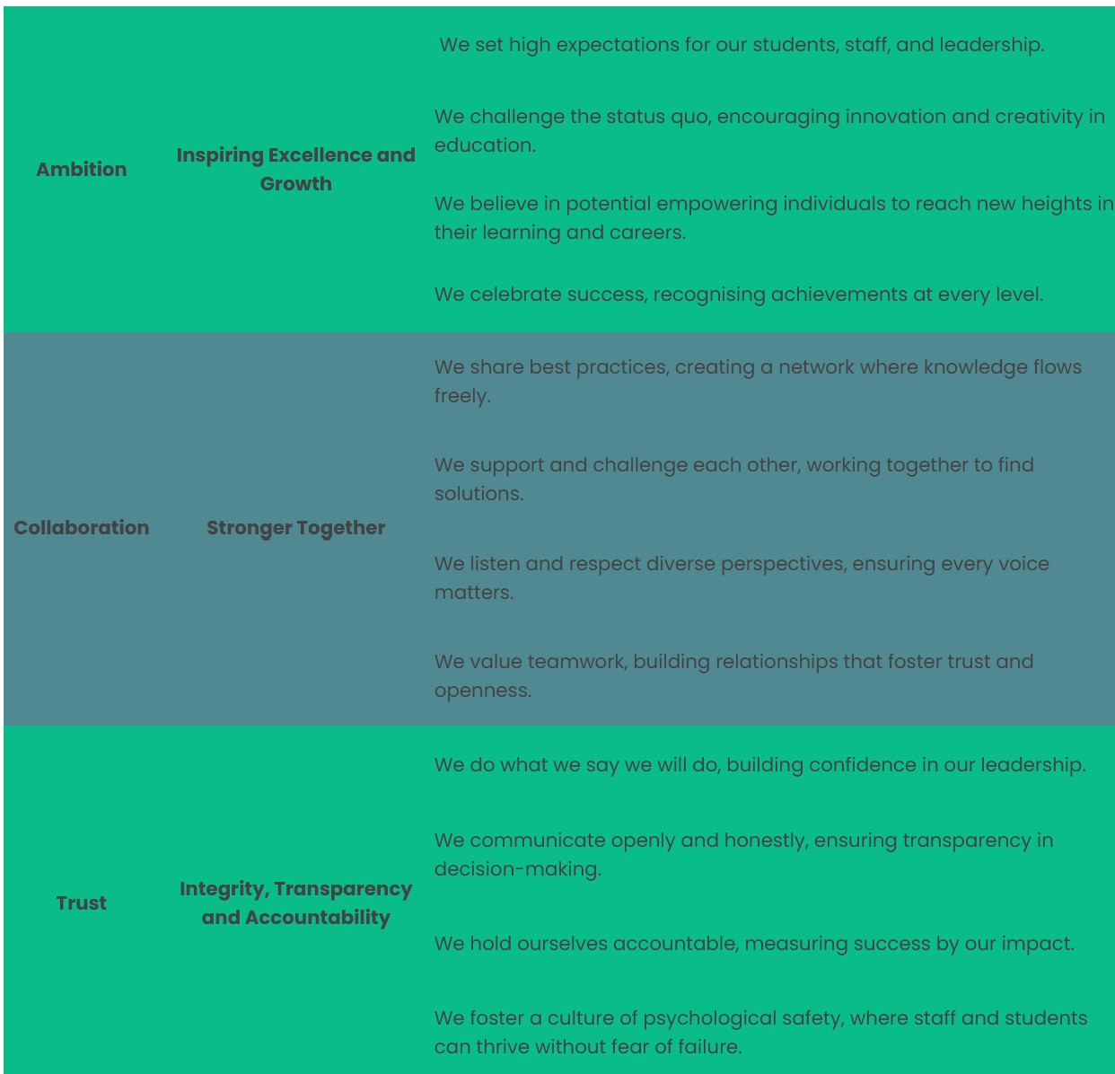
Three associated behaviours follow from each value. These are fundamental to building strong learning communities and creating the best possible environment for all members of those communities to flourish.

13. Recognition, reward and praise
The school recognises that praise is key to making pupils feel valued and ensuring that their work and efforts are celebrated. When giving praise, teachers ensure:
- there is a link to our values.
- they define the behaviour that is being rewarded.
- The praise is given immediately following the desired behaviour
- The way in which praise is given is varied.
- Praise is related to effort, rather than only to work produced.
- Perseverance and independence are encouraged.
- Praise is only given when a pupil’s efforts, work or behaviour needs to be recognised, rather than continuously without reason.
- The praise given is always sincere and is not followed with immediate criticism.

Whilst it is important to receive praise from teachers, the school understands that peer praise is also effective for creating a positive, fun and supportive environment. Teachers encourage pupils to praise one another, and praise another pupil to the teacher, if they see them modelling good behaviour.
As with praise, the school understands that providing rewards after certain behaviour means that pupils are more likely to model the same behaviour again. For rewards to be effective, the school recognises that they need to be:
- Immediate – immediately rewarded following good behaviour
- Consistent – consistently rewarded to maintain the behaviour.
- Achievable – keeping rewards achievable to maintain attention and motivation.
- Fair – making sure all pupils are fairly rewarded.

We want pupils to be motivated by the intrinsic values of ambition respect and collaboration however we are also committed to acknowledging pupils when they develop good learning habits. We seek to use descriptive praise and positive framing to signal to pupils that they are demonstrating good learning habits. Pupils will be nominated for hard work, strong progress or demonstrating a real commitment to our trust values.
‘Value Tokens’ are rewarded in class for individuals or groups who demonstrate one of our values (ambition, collaboration and trust). Each group/table in class has a collection of these tokens which are collected and counted at the end of the week. The reward for the most tokens can be given to the group at the teacher’s discretion. Each teacher may have a different reward: examples could be treats, first group out to playtime, names on a celebration display etc. Class teachers change the seating plan every half term to allow for new combinations of children (alternative arrangements may be made for SEN). In EYFS only, pompoms are collected in a class jar to reward positive behaviour.
Exceptional work or behaviour will be rewarded with a gold token from the class teacher for that child to contribute to the team (Pendle, Weets, Hamledon, Boulsworth). This is rewarded to the individual for work or behaviour above and beyond what is ordinarily expected of them. Headteacher/SLT can reward with a head teachers token, worth 2 of the gold token.
Additional examples of recognition and reward includes: sharing work with the class; sharing work with another teacher or the headteacher.

14. Detentions and Corrections
DfE guidance defines a detention as ‘a commonly used sanction often used as a deterrent for future misbehaviour. It is typically a short period where the pupil is required to remain under supervision of school staff when their peers have been allowed to go home or go out for lunch or break. Use of detention outside of the normal school day is lawful if safety considerations have been applied and the Headteacher has clearly communicated to families that this form of sanction may be used.

15. Isolation and Reflection
All of our schools have the power to use supervised reflection and isolation spaces as a disciplinary sanction and often as a way of avoiding fixed term exclusion. All schools will ensure that time spent in isolation is used as constructively as possible, that there is a continuation of education and that pupils are allowed to eat, drink and use the toilet. Any removal from a classroom is considered a serious sanction and is only used when necessary to restore order, following unreasonable levels of disruption. Removal will only be used once classroom management strategies have been attempted or if the behaviour is extreme enough to warrant removal.

16. Reasonable Force
Reasonable force can be used to prevent pupils from committing a criminal offence, hurting themselves or others or from damaging property. More detailed information on the use of reasonable force can be found in our Physical Intervention Policy.

17. Fixed term and Permanent Exclusion
All of our schools work tremendously hard to avoid and fixed term and permanent exclusion but at times it can be necessary to address a more serious behaviour matter. All of our schools comply with the law and communicate with families clearly. More information can be found in our Exclusions Policy.

18. Apex Collaborative Trust Learning Habits
All members of staff are expected to actively promote and model the Apex Collaborative Learning Habits.

1.Perfect uniform
We will insist on perfect uniform: not nearly perfect but perfect. We expect all pupils to wear their uniforms neatly and with pride. It is important that pupils contribute to our schools’ common routines. If pupils breach any one part of our strict uniform code, then they will be given some temporary uniform to wear and conversation will take place with parents. We will do this to ensure that all our pupils take pride in their appearance and to make sure that our pupils are treated fairly. It is unfair if some pupils keep to our dress code, and some don’t. Further detail around specific uniform expectations can be found in the parent/ carer contract.

2. Punctuality & attendance
All pupils should attend school and classes on time, every time. We are trusting that pupils will arrive at the school by 8:45 each day so that they are ready for the day’s learning. Pupils who arrive late to school are expected to sign in at reception. Anything less than 96% is not good enough and the school would expect this only to be the case for pupils with serious medical issues or exceptional circumstances. If pupils are ill then parents/carers must contact the Academy on the morning of each day of absence. Any planned absence should be requested using the schools’ leave of absence form. Any holiday request during term time will be refused. We trust that parents will only request leave of absence in exceptional circumstances.

3. On-task behaviour
We insist on focused learning in the classroom to ensure that learning is maximised for all pupils. Pupils who wish to succeed are always on-task in every lesson and behave in a purposeful manner outside of lessons. Sometimes, it will be hard work for pupils to remain on task but we will remind them that they learn best when they are concentrating. It also means that other pupils can learn without disruption and allows the teacher to teach what s/he has planned. We expect all pupils to track (eyes on me) the person who is talking to demonstrate that they are listening carefully.
Pupils are expected to remain quiet during lessons and when transitioning around school.
When in lessons or assemblies, pupils are expected to remain in silence until they are invited to speak by the member of staff leading the lesson or assembly. Staff members will raise their hands to show that they want silence and it is expected that pupils respond immediately by also raising their hand and becoming silent.
Failure to be on-task in lessons or around the school will result in a correction on the same day as the off-task behaviour. Failure to be on-task on more than one occasion on any given day will result in an extension to the correction session. Continued disruption in one lesson may result in isolation.

4. Prepared for learning (homework, deadlines, equipment)
Pupils should arrive at school with the right equipment, so that no learning time is interrupted. Pupils do this by having the right PE kit, book bag and reading book and homework when applicable.
We wish to develop our pupils’ organisational skills for success in future life. For any important role in life, we need the right equipment and pupils and parents need to make sure they provide it.
All stationery will be provided by the school which means no pupils should bring in their own stationery from home. Pupils should not be carrying bags or wearing coats around the school.
Illegal items, chewing gum and jewellery (other than one plain watch and stud earrings which are taken out or taped for PE) are not allowed in the school. Fruit or vegetables only is allowed for a snack at breaktime.
Mobile phones are not to be seen or heard in the school. We would strongly recommend students do not bring a mobile phone into the school. If parents want their child to bring a phone to school for safety reasons, they must be switched off and handed in to the teacher (we cannot accept any responsibility for lost or stolen possessions). If a member of staff sees a mobile phone it will be confiscated and will be kept until a parent/carer collects it. If pupils fail to be prepared for learning, they will receive a correction on the same day that they failed to demonstrate this vital learning habit.

5. Follow staff instructions first time, every time
Pupils are expected to demonstrate respect for all adults all of the time; this means no refusal to follow instructions first time. We know that pupils who wish to succeed do not refuse to follow instructions and trust that teachers’ instructions are to help them be successful. We know it is important that students learn self-discipline. If an adult tells a pupil to do something, we expect it done straight away. If pupils fail to demonstrate this learning habit they may then cross the ‘red line’ resulting in isolation or exclusion. If a pupil feels unfairly treated they must still follow the instruction first time, every time. Later, pupils will be given the opportunity to discuss the incident and reflect on the situation and the decision made. Pupils are expected to speak to all members of the school with respect and courteously.

19. Managing Low Level Behaviour Low level behaviour includes:
- Talking at inappropriate times
- Walking around the classroom without permission.
- Shouting out
- Making inappropriate or rude noises
- Attempting to upset others
- Purposefully damaging equipment

Instances of unacceptable behaviour are taken seriously and dealt with immediately.
After an initial incident of low level negative behaviour, the following sanctions are:
Disruptive behaviour
- Reminder given through positive framing.

Behaviour continues
- Verbal warning given to the child and consequences of the action explained; positive framing and reinforcements when positive behaviours are demonstrated. Behaviour continues
- Immediate playtime missed. Reflection room.

Behaviour continues
• Second playtimes missed. Reflection room. Parents informed (phone call).

Behaviour continues
- Parents meeting
- Removal of privileges (i.e. after school clubs, visits, etc) Behaviour continues

Child works in SLT or behavior leads classroom for next session.

Or
- Internal isolation – with SLT supervision. Appropriate and relevant work to be provided by the class teacher and face to face meeting with parents and class teacher behaviour contract put in place. Behaviour continues
- Parents meeting and behaviour agreement.
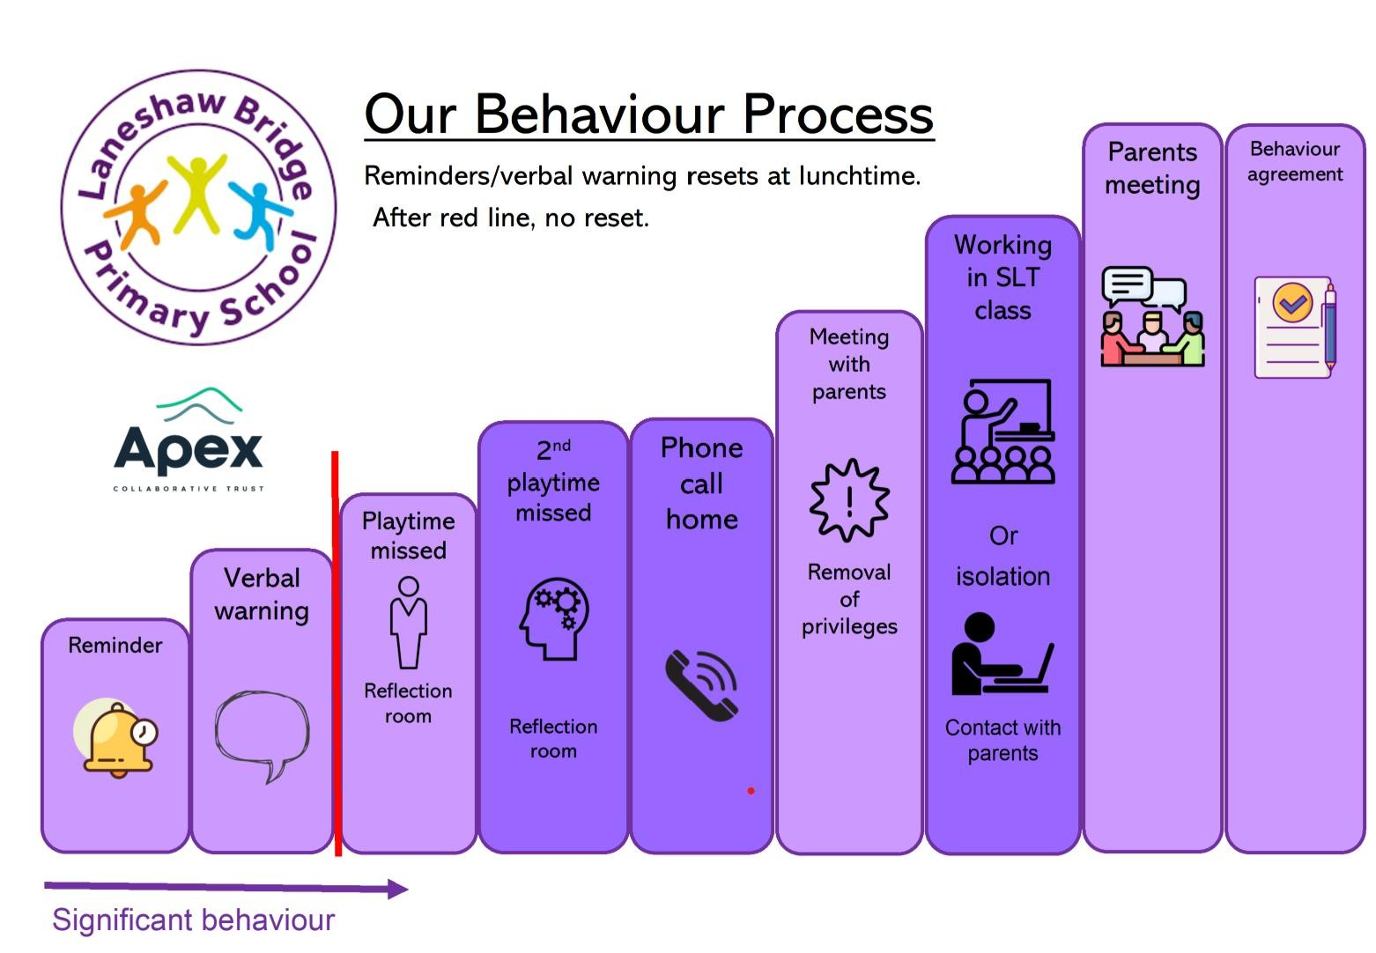

The sanction process before the red line resets at 12pm and end of day.
Lunchtime in Hall – as above
Yard – as above
Breakfast Club – as above
After school club:
Disruptive behaviour
- Reminder given through positive framing.

Behaviour continues
Verbal warning given to the child and consequences of the action explained; ongoing reminders and reinforcements when positive behaviours are demonstrated. Behaviour continues
• A child will move to the street (corridor).

Behaviour continues
- Immediate playtime missed. Conversation to be had with a member of SLT or behaviour lead reflecting on behaviour. Behaviour continues
- As above

20. Managing significant behaviour
Significant behaviour includes:
- Using abusive/bad language towards adults or other children, including racist, homophobic, transphobic, sexist or discriminatory comments
- Using physical violence towards others
- Continued damaging of equipment
- Becoming defiant towards adults.
- Any low level behaviour that is regularly repeated (over the course of a day).

Significant behaviour
- Reflection completed, parents informed (phone call).
- Behaviour log issued, child works in SLT or behaviour leads classroom for next session.

Behaviour repeated following support
- Internal isolation – with SLT supervision. Appropriate and relevant work to be provided by the class teacher and face to face meeting with parents and class teacher behaviour report card put in place.
- Removal of privileges (i.e. after school clubs, visits, etc) Behaviour repeated following support
- Internal isolation – HT - Appropriate and relevant work to be provided by the class teacher and face to face meeting with parents and class teacher behaviour report card put in place.
- Removal of privileges (i.e. after school clubs, visits, etc)

Behaviour continues more frequently following support (external agencies may be used)
Temporary exclusions.
- Exclusion - The headteacher will consider whether the pupil should be excluded for a fixed term, in line with the school’s Exclusion Policy, and will determine the length of the exclusion.
- Although unacceptable behaviour does not necessarily mean a pupil has SEND, an assessment will be carried out at this stage to determine whether there are any undiagnosed learning or communication difficulties, or mental health issues that may be contributing to the pupil’s behaviour.
- Where a pupil is identified as having SEMH-related difficulties, SEND support will be put in place from school’s national SEND budget.
- Where SEND is not identified, but the headteacher determines that support is still required for the pupil, an Individual Behaviour Plan will be created to outline the necessary provisions in place.

Following further incidents of unacceptable behaviour, the following sanctions are implemented:
For discipline to be lawful, the school will ensure that:
- The decision to discipline a pupil is made by a paid member of school staff, or a member of staff authorised to do so by the headteacher.
- The decision to discipline a pupil is made on the school premises or whilst the pupil is under the charge of a member of staff, such as during an educational trip or visit.
- The decision to discipline a pupil is reasonable and will not discriminate on any grounds, as per the Equality Act 2010.
The school will ensure that all discipline is reasonable in all circumstances, and will consider the pupil’s age, religious requirements, SEMH needs, any SEND, and any other relevant information.

21. Prevention strategies and sanctions for unacceptable behaviour
This section outlines the school’s strategies for preventing unacceptable behaviour, minimising the severity of incidents, and using sanctions effectively and appropriately to improve pupils’ behaviour in the future.

Positive teacher-pupil relationships
Positive teacher-pupil relationships are key to combatting unacceptable behaviour. The school focusses heavily on forming these relationships to allow teachers to understand their pupils and create a strong foundation from which behavioural change can take place.

De-escalation strategies
Where negative behaviour is present, staff members will implement de-escalation strategies to diffuse the situation. This includes:

- Appearing calm and using modulated low tone of voice.
- Using simple, direct language.
- Avoid being defensive, e.g. if comments or insults are directed at the staff member.
- Provide adequate personal space and not blocking a pupil’s escape route.
- Showing open, accepting body language, e.g. not standing with arms crossed.
- Reassuring the pupil and creating an outcome goal.
- Identifying any points of agreement to build rapport.
- Offering the pupil a face-saving route out of confrontation, e.g. if they stop the behaviour, then the consequences will be lessened.
- Rephrasing requests made up of negative words with positive phrases, e.g. “if you don’t return to your seat, I won’t help you with our work” becomes “if you return to your seat, I can help you with your work”.

22. Physical intervention
In line with the school’s Positive Handling Policy, staff have the legal right to use reasonable force to prevent pupils from committing an offence, injuring themselves or others, or damaging school property, and to maintain good order and discipline in the classroom.
Physical restraint will only be used as a last resort and as a method of restraint. Staff members will use their professional judgement of the incident to decide whether physical intervention is necessary. The situations in which physical restraint may be appropriate are detailed in the Positive Handling Policy.
Wherever possible, staff will ensure that a second member of staff is present to witness the physical intervention used. After an instance of physical intervention, the pupil will be immediately taken to the headteacher and the pupil’s parent will be contacted – parents may be asked to collect the pupil and take them home for the rest of the day.
Any violent or threatening behaviour will not be tolerated by the school and may result in a fixed-term exclusion in the first instance. It is at the discretion of the headteacher as to what behaviour constitutes for an exclusion.
When using reasonable force in response to risks presented by incidents involving pupils with SEND or medical conditions, the school will recognise and consider the vulnerability of these groups

23. Isolation room/space
The school may decide to move pupils to a separate room away from other pupils for a limited period.
The school will only move pupils to isolation rooms where absolutely necessary. The school will ensure that pupils’ health and safety is not compromised during their time in the isolation room, and that any additional requirements, such as SEND needs, are met.
The amount of time that a pupil spends in the isolation room will be up to the school to decide. This could be for more than one school day. The school will ensure that the pupil is not kept in isolation any longer than necessary.
The staff member in charge and supervising the pupil will decide what the pupil may and may not do during their time spent in isolation. The headteacher will request that the pupil’s class teachers set them appropriate work to complete.
Pupils are permitted to eat during the allocated times of the school day and may use the toilet as required.

24. Appendix one – Behaviour report card
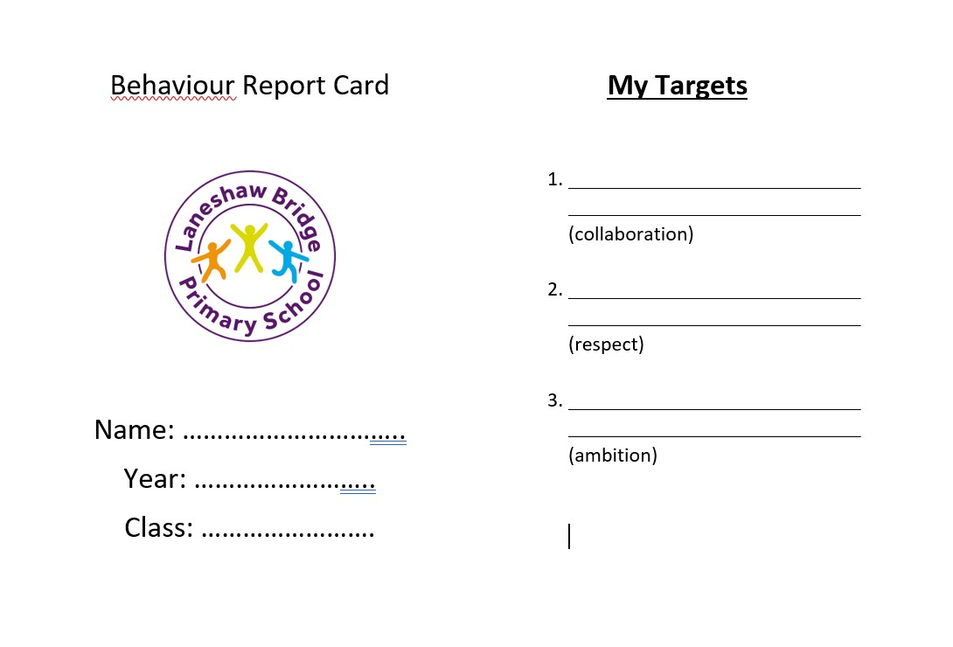

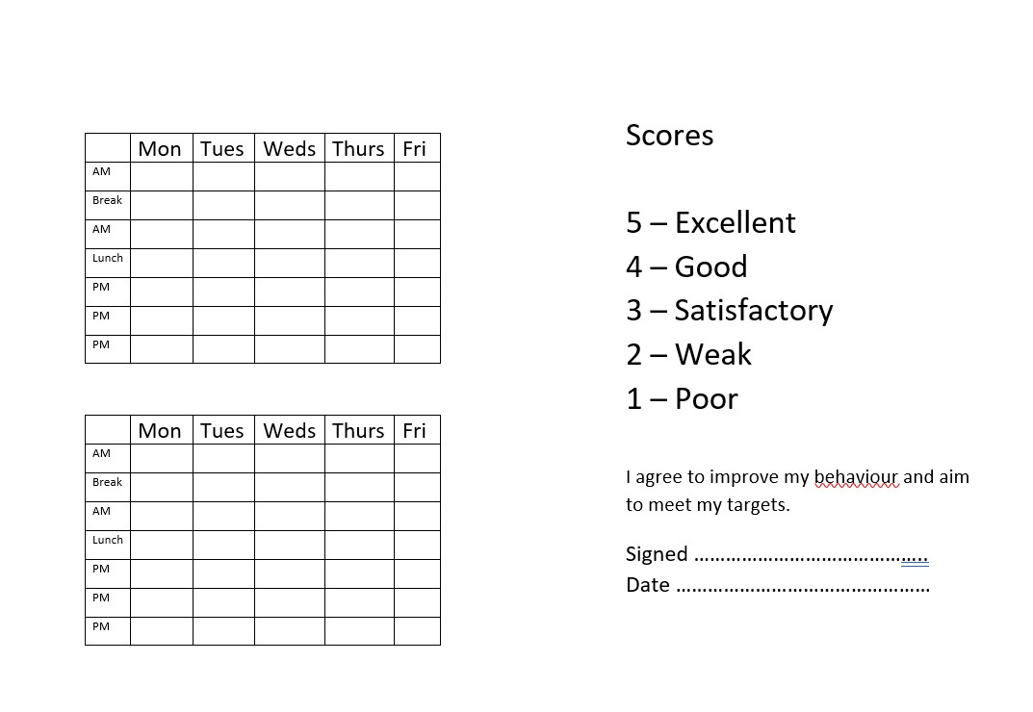

19

